Project- 1
User Stories
User Story 0001: Add the Train option when country is ‘UAE’
Description: The scope of this US is to provide the Train option when country is UAE so that users can able to search/find the train across the country
Acceptance Criteria:
    - Users are able to click on the train icon
    - train icon is displayed after the Hotels icon (as per the mock-up)
    - When user click on the Train Icon the browser title should display as: MakeMyTrip Online Train Ticket booking- UAE
Mock-up:

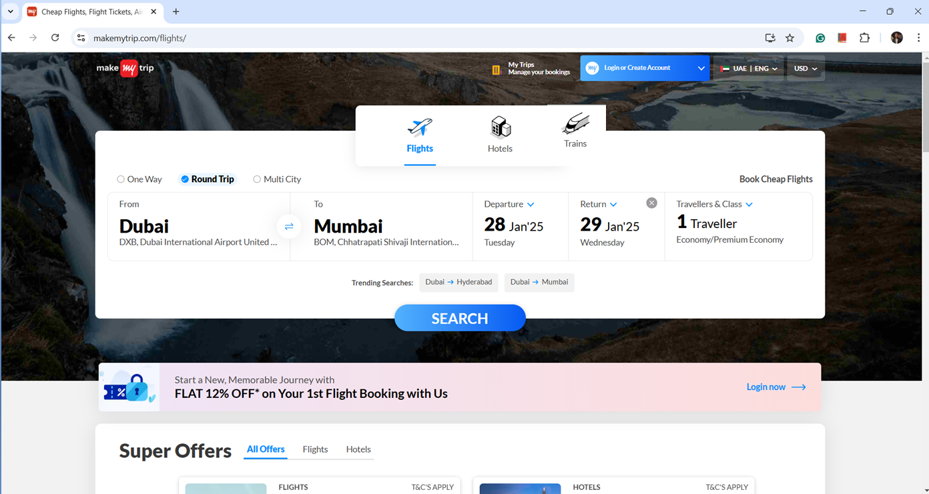

Part 1 Instructions
In the Make My Trip application as per the client requirement the development team is adding a new the Train option when user select the country as ‘UAE’ for this functionality all the mock-ups and acceptance criteria are present in the user story. Please go through the user story and complete all the subtasks.

Subtasks
    - Write the test scenario and test cases based on the acceptance criteria for the newly implemented functionality.
    - Estimate your testing effort (Provide the story point) how much time you will require to complete the QA testing activity.
    - While testing the newly implemented functionality you find the bug i.e.. If user select the ‘Train’ option and switch to the Hotel icon the page is not loading. Please give Priority of the bug.
    - Provide the severity for the same issue.
    - Prepare the Regression checklist for the newly implemented functionality.

Test Scenario and Test cases Writing Format

scenario: 1

Sl no. | Test Cases | Expected Result

